SQL

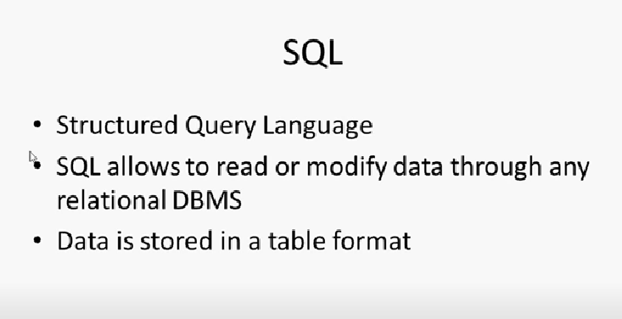

SQL allows to read or modify data through any relational Database like oracle ,DBMS, SQL,MYSQL etc

Data is stored in a table format which is in the form of rows and colums

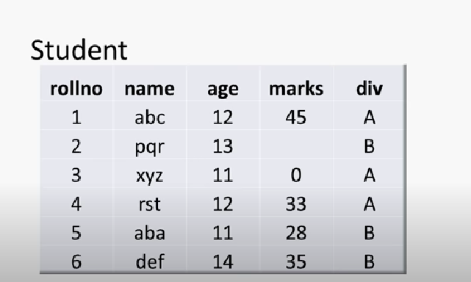

The columns roll no , name , age are called attributed

Using SQL u can create , insert , update or retrieve the existing information from the table

* For doing this tasks u need to write some sql statements which is called “queries”
* We write sql queries to read information , to write information
* We usually use two types of sql queries one is DDL (Data Definition Language)and other one is DML (Data manipulation language)
* For example We use DDL for specifying the columns which table need to has and along with datatype
* But by Executing the DDl we cant get the data from the table, we only get blank table without data
* In order to insert data, retrieve data , Update and delete the data we use DML queries

DDL : It’s a language used to define data structures and modify the data

These commands are basically used to define the fundamental definition of database objects(tables, views, index etc)

We can define database objects structure and modify the structure or delete the structure

Create, Alter, drop, truncate, Rename these are commands which is used for DDL

CREATE: create is used to create the structure of database objects

What ever we store in the database is called objects tables, views, triggers

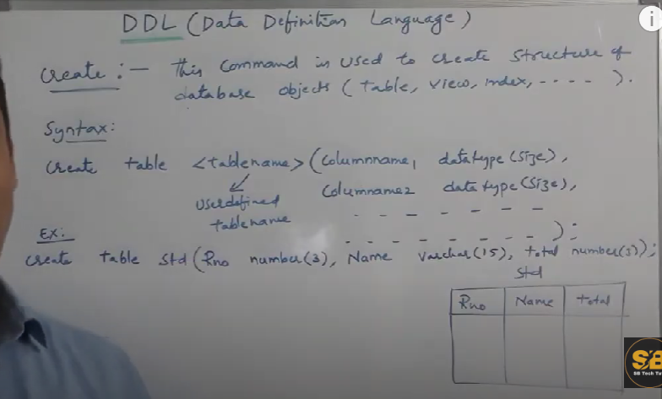

Create table tablename(column name1 datatype(size),

Columnname 2 datatype (size),

Columnname 3 datatype (size));

For the above example student :

Create table student(Rno number(3), Name varchar(15), total number(3));

Alter : Alter command is used to update the table structure

* Alter is used to update new column , or update the existing column
* Alter is used in two ways add and modify
* 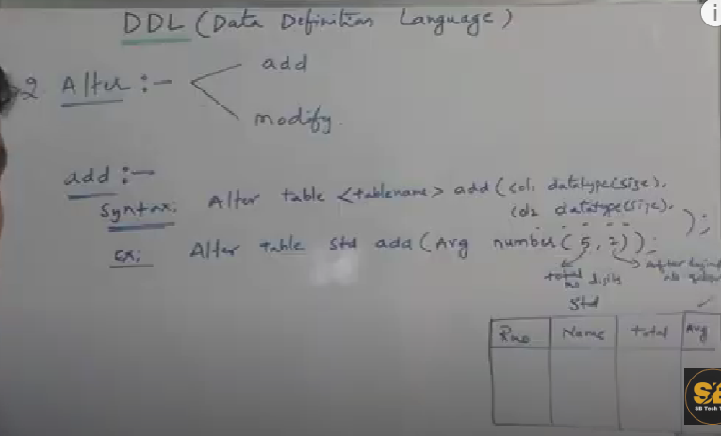

Syntax: Alter table tablename add(column 1 datatype(size),

Column 2 datatype(size));

Example from the above pic u want to add avg as a new column

So for add or update u will use alter table

Alter table student add(Avg number(5,2)); --- fir shows total number count 2nd shows how many points it would be

As 5 digits number and decimal point should be in 2nd digiti ex 567.39

Modify : to modify existoing column

Syntax: Alter table tablename modify (column 1 datatype(size)

Column2 datatype(size)

Column3 datatype(size));

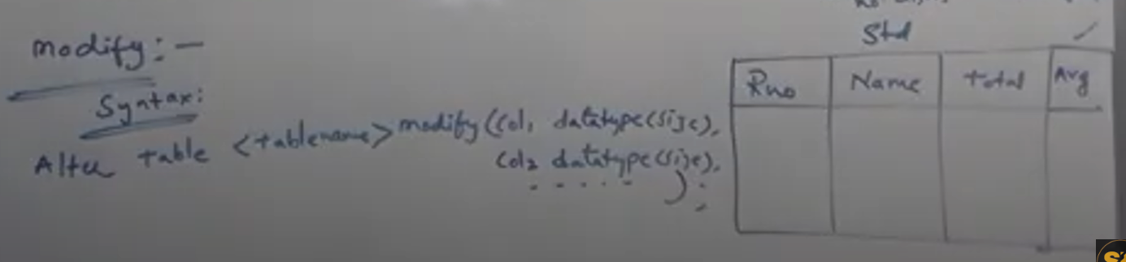

Ex: from above table

Alter table studentname modify(Avg number(7,2));

U r modifying size in this query

3. Rename Command: To Rename the existing table we use Rename command

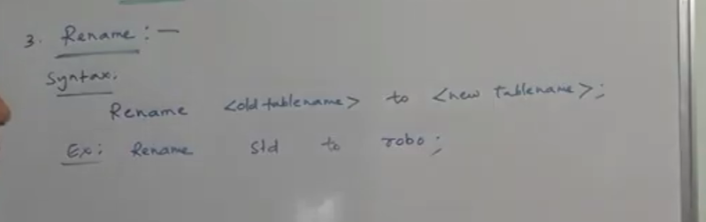

Rename syntax:

Rename <old table > to <new tablename>;

Ex: Rename student to Faculty;

4. Truncate: If u want to delete complete records of a table u can use truncate

Syntax: Truncate table <tablename>;

Truncate table faculty;

The above query deletes all the records by using truncate command structure will be there only records gets deleted

Before truncate: (only records deletion)

After truncate:

Drop : drop is used for delete the records as well as it also deletes the entire structure of the table

Syntax:Drop table <tablename>;

Ex: drop table faculty; records + structure deletion

* DDL means structure related (for structure creation, modification , deletion we ddl queries)
* DML means data related   
  (database objects modification or manipulation ) we use DML like data insert,select,update, delete
* 

Insert command is used to insert values in a database objects like table,views

In insert command u can insert 1 record at a time

* You cannot insert multiple records through insert
* Syntax: insert into <table name> values(list of values order wise);

Example:

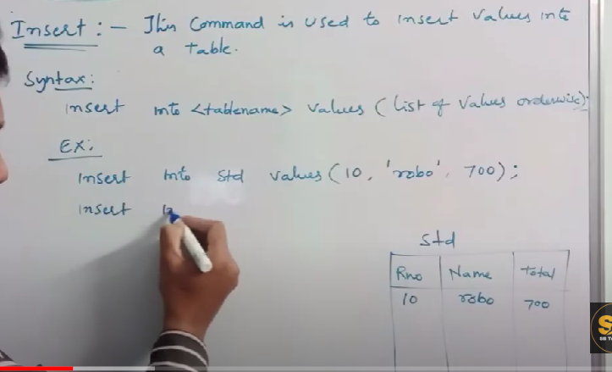

Insert into std values(10, ‘robo’,700); it inserts column wise 1st value gets into rno , 2nd value into name, 3rd value inserts in total

2) select: select command is used to display or retrieve records from data base objects like table ,view etc

Ex: select * from <table name> ; ----- * represents all columns

The above query gives all the records from the table

Ex: if u want only selected records from the table

Select <column-list > from <tablename>;

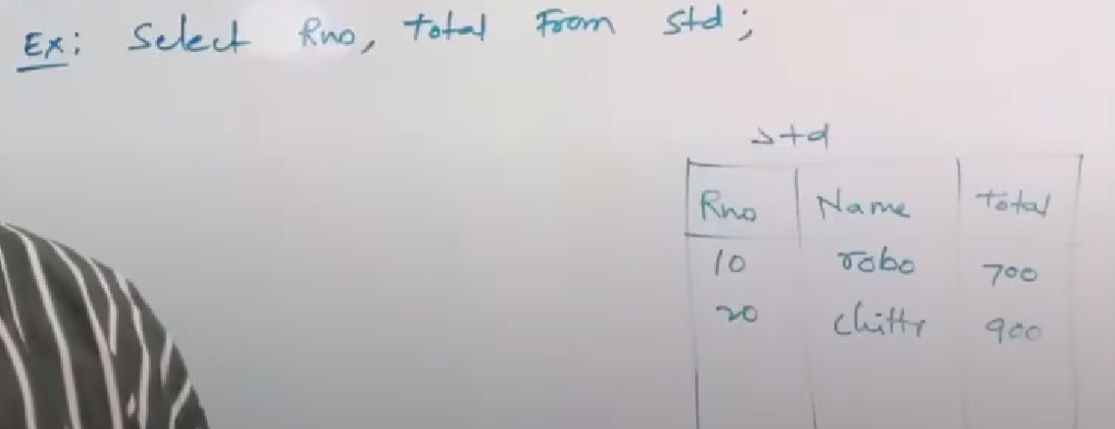

From above example if u want only rno and total to be displayed u will use

EX: Select RNO, TOTAL from Std;



3rd type select : if u want only one whole record where roll no =20

Syntax: select <col-list> or * from <table_name> where condition;

Ex: Select * from std where rollno=20;

Out put : rollno 20,name chittu, total 900

Update: Update is used to modify the data of a table

Difference btw alter and update :

Alter is used to modify the table structure where as update is used to modify the data

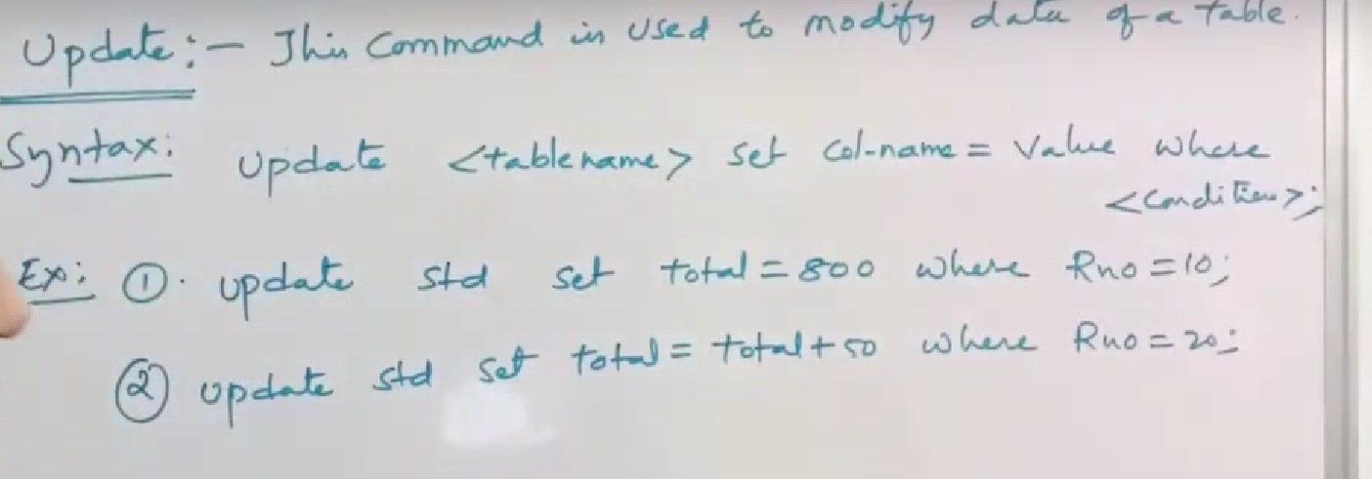

Syntax: update tablename set colname=value where condition;

Ex: update std set total = 800 where Rno=10;

Ex: update std total=total+50 where Rno= 20;

Delete: Delete is used to delete particular record from a table

Diff b/w delete,truncate and drop

Delete is used to delete particular record or collection of records

Truncate is used to delete the entire records except table structure

Drop is used to delete entire records from a table along with structure

Delete syntax: delete from <tablename> where <condition>;

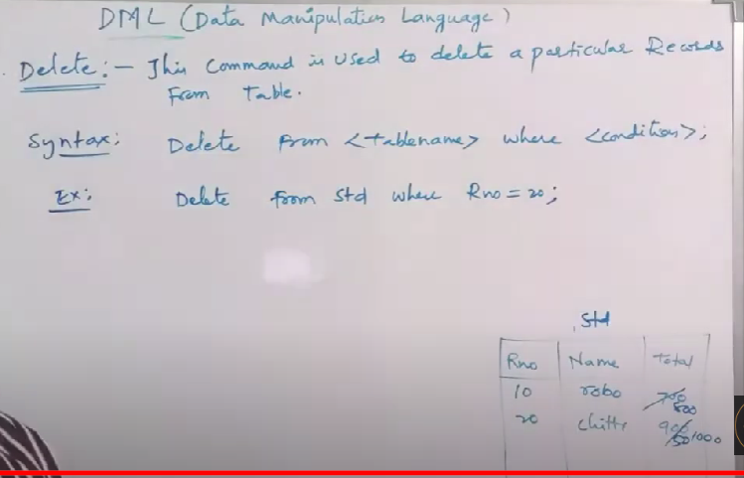

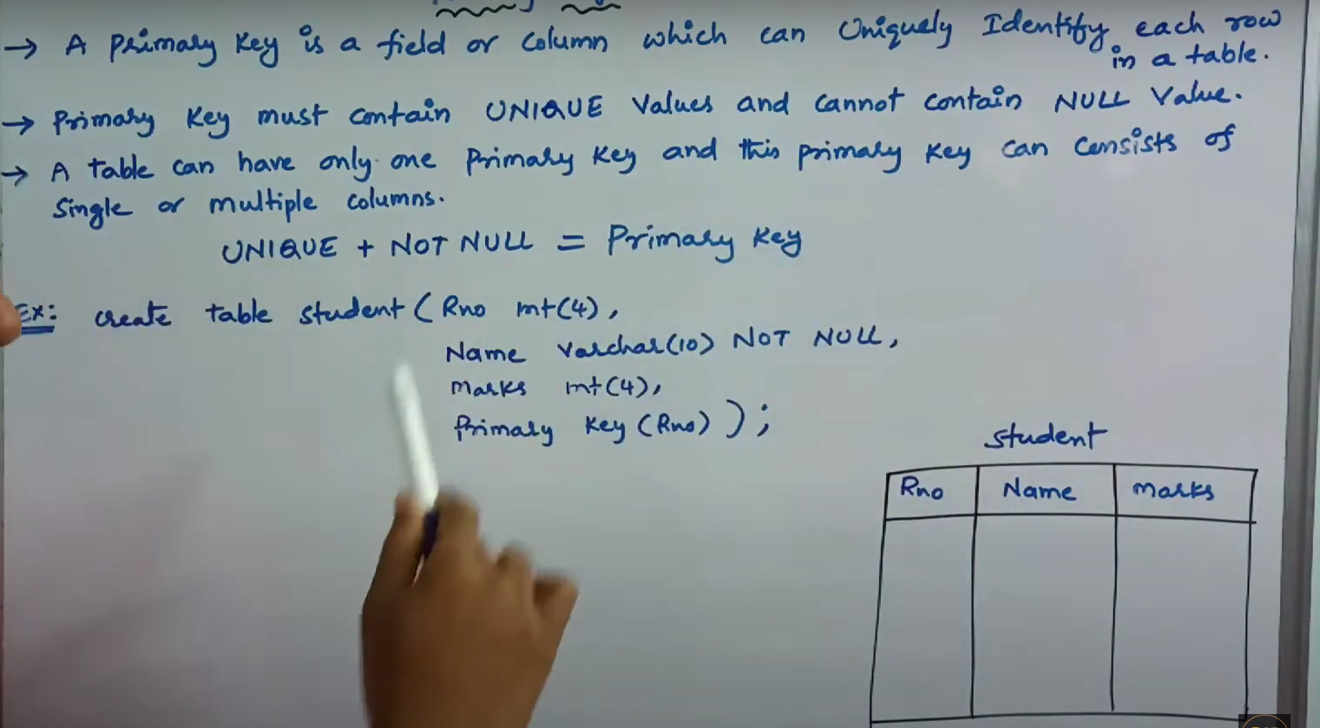

**A primary key** is the key which is a unique column in a table which doesnot allows u a duplicate values and also doesnot allow null values

Unique + not = primary key

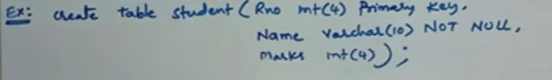

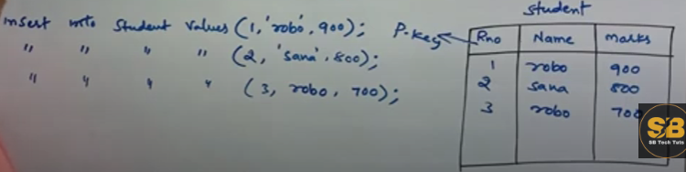

Create table tablename(rollno int(5) primarykey,

Name varchar(8) Not null,

Marks int(4));

Insert into tablename values(1, ‘robo’,800);

Insert into tablename values(2, ‘sravya’ 500);

**Foreign Key : Foreign** key is the key which builds the relationship between tables there should be the same column in both the tables so 1 which is primary key relates to the same column in another table which is called foreign key

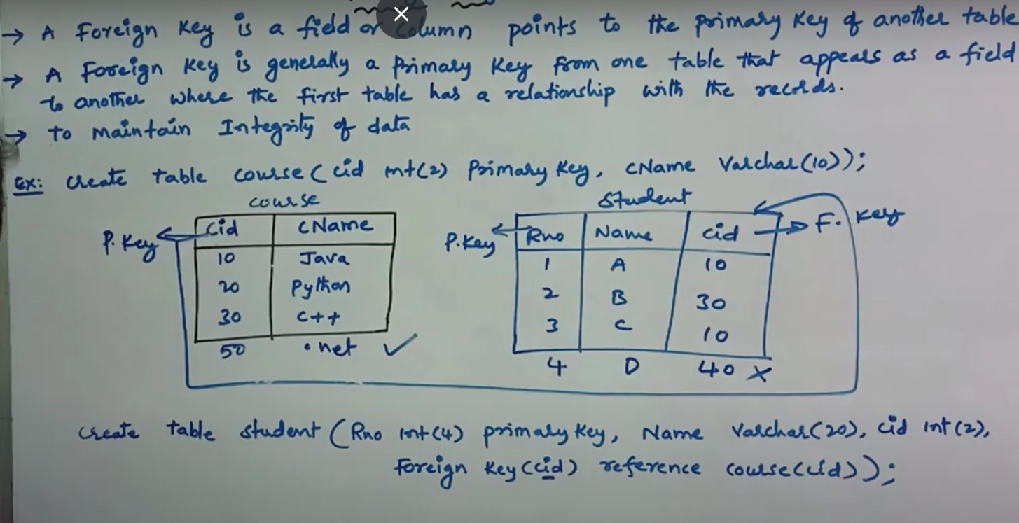

If we are inserting records in foreign key which doesnot have in primary key it throws error

In the above example cid in course section is a primary key and in student table

So in course table there is no 40 in cid column so when we are inserting the cid as 40 in student section it doesnot allow it throws an error so foreign key also used for integrity of the data…

Create table course(rollno int(4) primary key , courseName varchar(10));

Create table Student(Rno int(4) primary key , name varchar(10), cid int(2), foreignkey (cid) reference course(cid));

**DATATYPES SUPPORTED IN SF**

1.Numeric datatypes : number (upto 38 digits,0)

decimal,

int , smallint,integer (upto 38 digits,0)

float,

double precision

2.string & binary datatypes: VARCHAR **(**Default), char,string,text,binary(upto 8mb (8388608 bytes)

3.date & time datatypes: date,datetime,time,timestamp

Create table employee( First_Name varchar(10),

Last_Name varchar(10),

DOB Date

Salary number(38,0));

Empid int emname varchar 250dob date salary dec 11,2 customer name cus dob cusid salary

Create table Customer(Emp_id integer,

Emp_name varchar (250),

DOB Date,

Salary Decimal(11,2),

Customer_name Varchar(250),

Customer_DOB Date,

Customer_id integer);

A fname varchar lastname 250

Alter table Customer add (First_Name varchar(250),

Last_Name varchar(250));

Entrim is used to trim the data when u give too much length

And also u need to give some size for varchar